**Lesson 9 Demo 2**

**Understanding Kubernetes Cluster Logging Architecture**



# Steps to be followed:

1. Getting help on logging
2. Experimenting with BusyBox
3. Logging pod information
4. Logging options and switch information

**Step 1: Getting Help on Logging**

1. Execute the following command to invoke the help menu:

***kubectl logs --help***

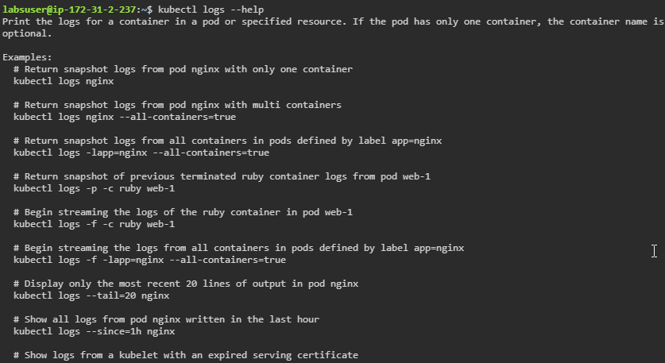

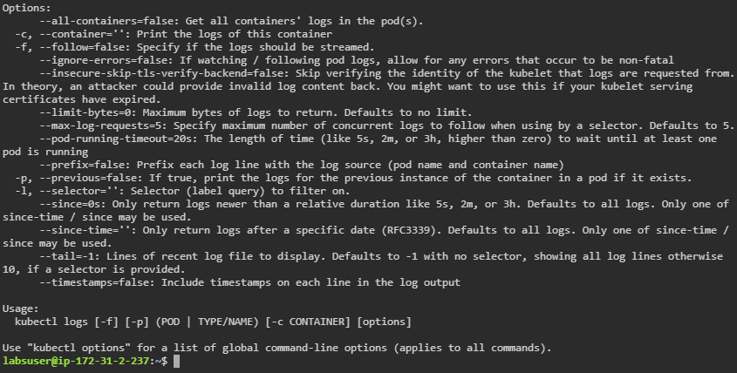

**Step 2: Experimenting with BusyBox**

1. Create a pod called busybox using the following command:

***vi busybox.yaml***

1. Include the following code in the file:

***apiVersion: v1***

***kind: Pod***

***metadata:***

***name: counter***

***spec:***

***containers:***

***- name: count***

***image: busybox***

***args: [/bin/sh, -c,'i=0; while true; do echo "$i: $(date)"; i=$((i+1)); sleep 1; done']***

1. Deploy the yaml file and check its logs using the below commands:

***kubectl apply -f busybox.yaml***

***kubectl get pods/counter***

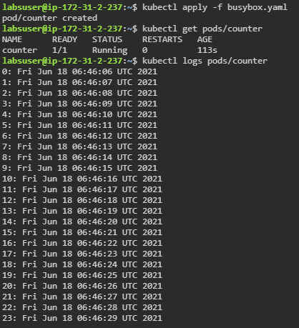

**Step 3: Logging Pods**

1. Execute the following command to get the last five lines of the log:

***kubectl logs <pod> --tail=5***

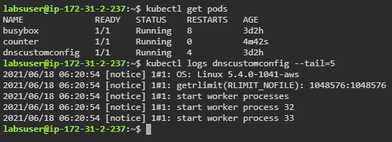

1. Run the following command to obtain the complete log:

***kubectl logs <name_of_service>***

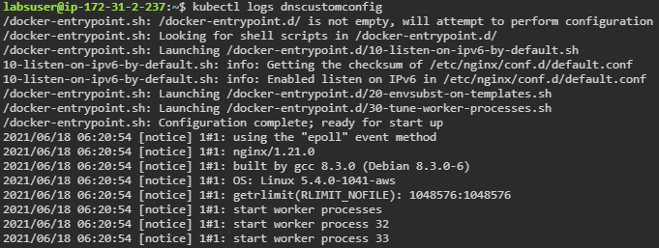

**Step 4: Logging Options and Switch Information**

1. Execute the following command to obtain the logs of all the containers in a namespace:

***kubectl logs --all-containers <name>***

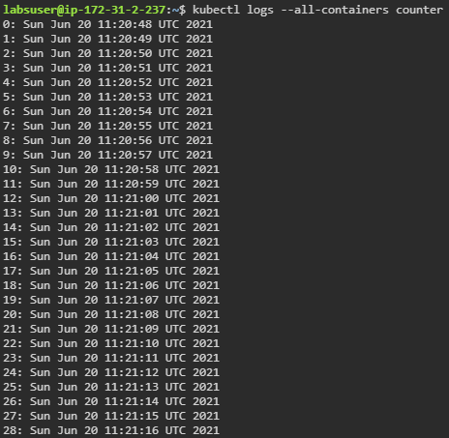

1. Execute the following command to obtain time-specific information using the below command:

***kubectl logs counter --since=<timespan>***

